This practice session, is about to explore some of the useful key strokes in the MS Window OS. Let’s begin…

**Part A:**

Please specify the key/command and capture the screen shot of “Open or close the Start menu”. E.g.

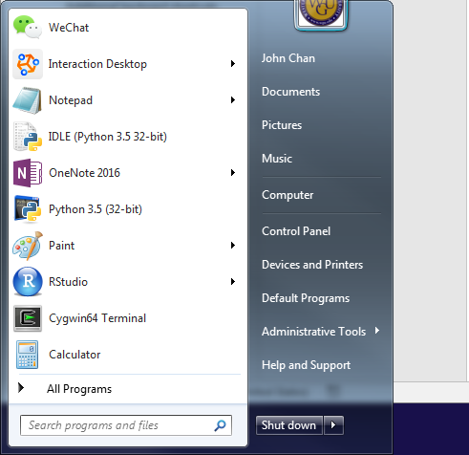

Ans: Clicking on the “WINDOWS” key or “ctrl+Esc”.

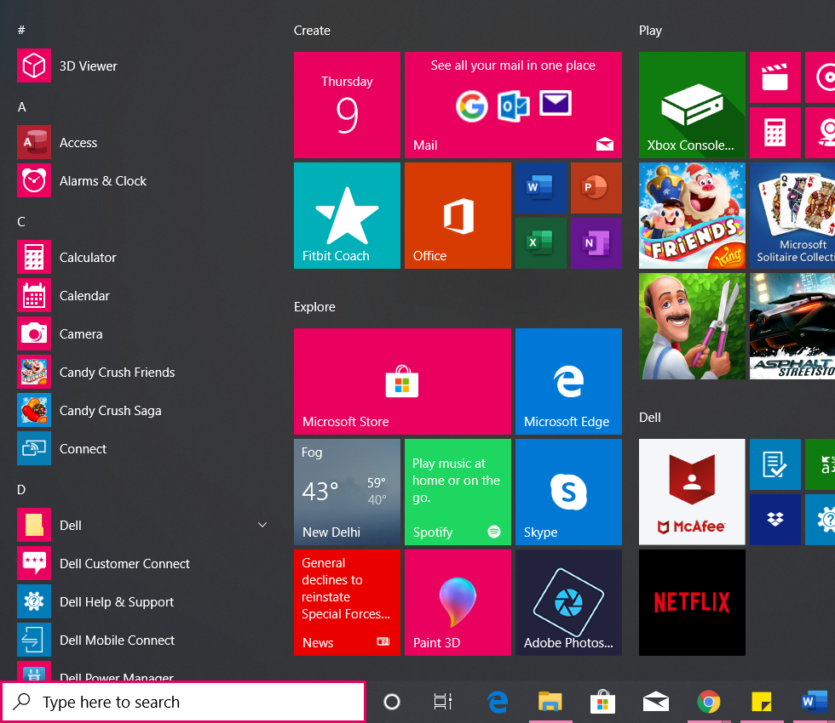

**Part B:**

You have too many windows open. Please specify the key/command to Display the desktop, and restore the many windows you have. Please capture your screenshots. E.G.

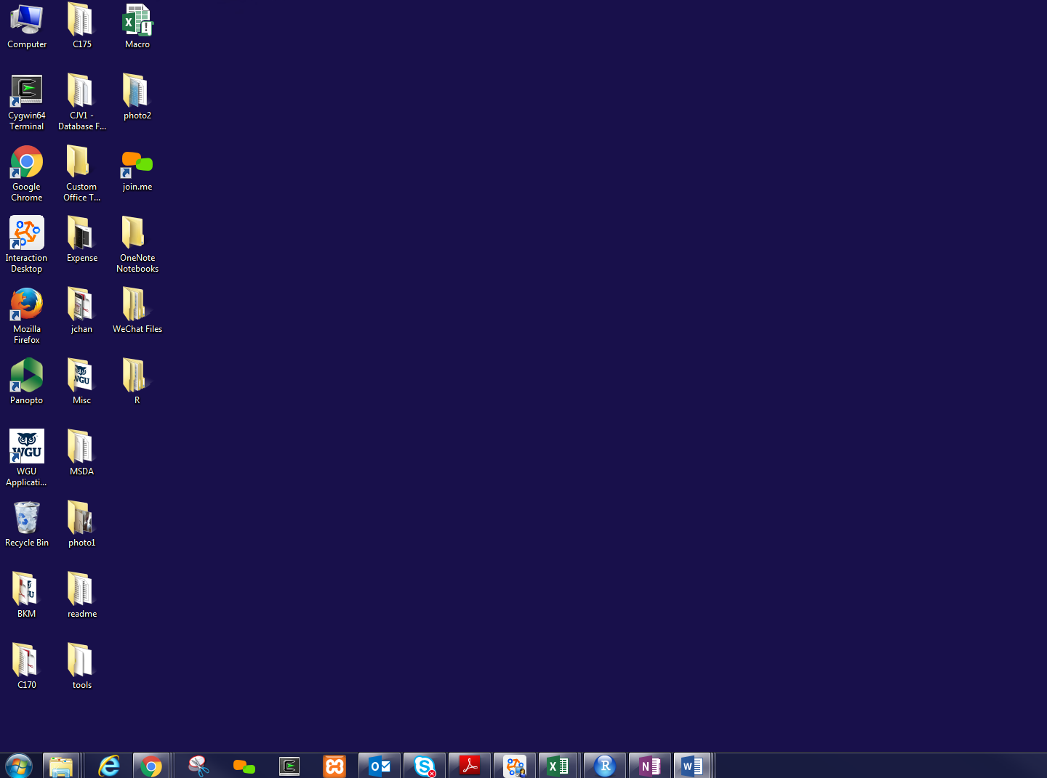

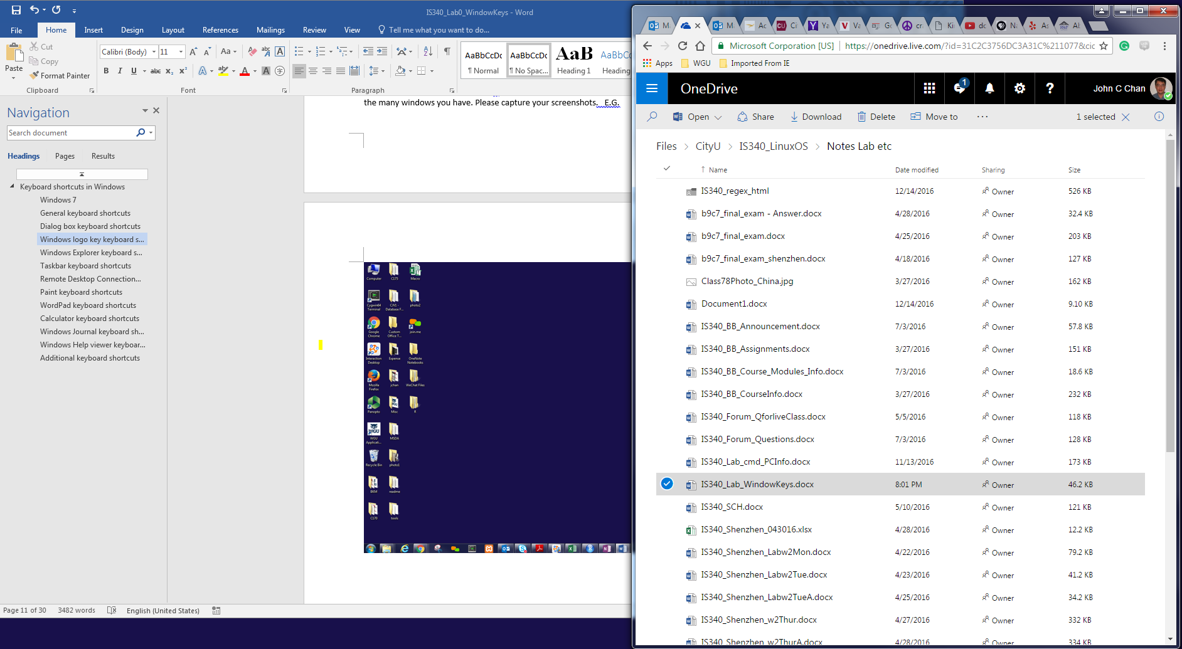

Ans: **Keys to Desktop**:

Windows **Key** + "D"

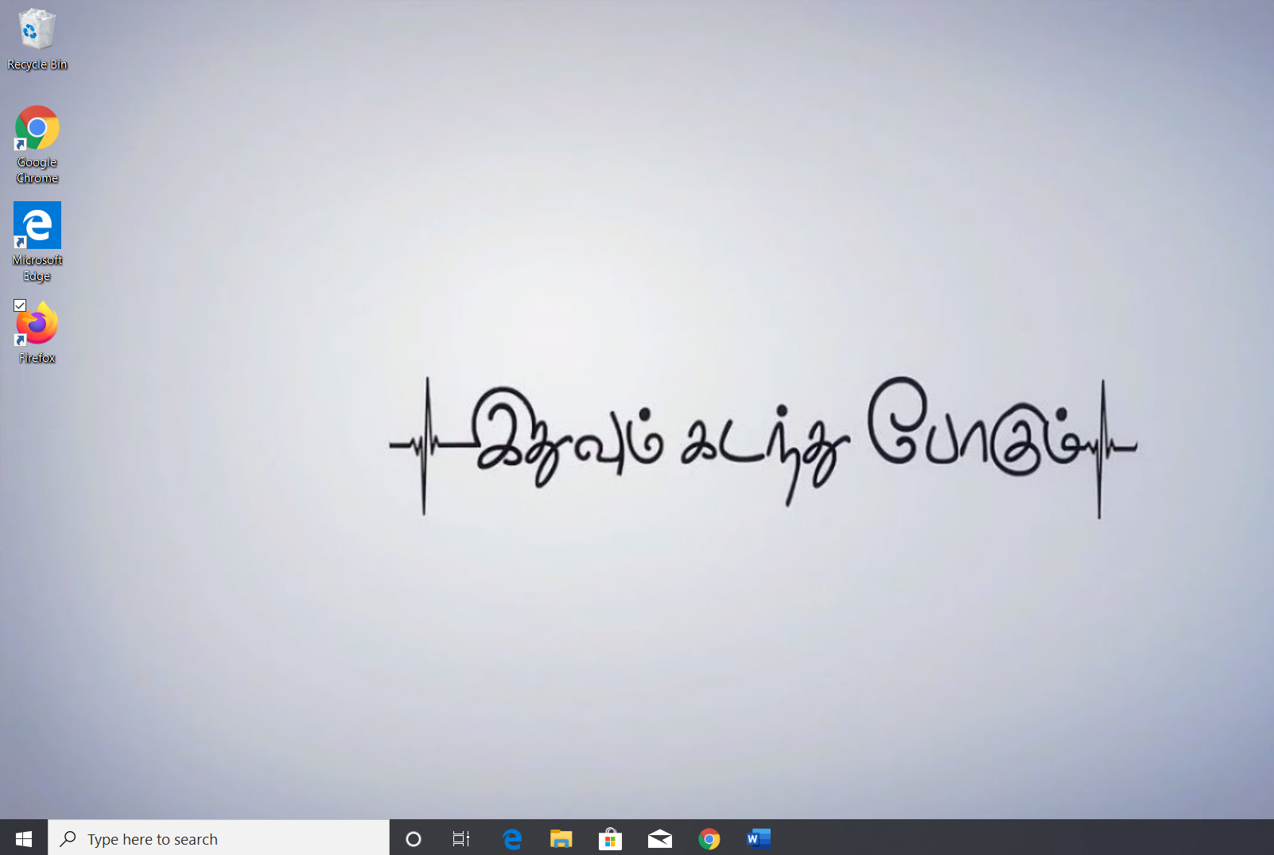

**Keys to Restore:**

Windows + Shift + M **Restore** minimized **windows** to the desktop

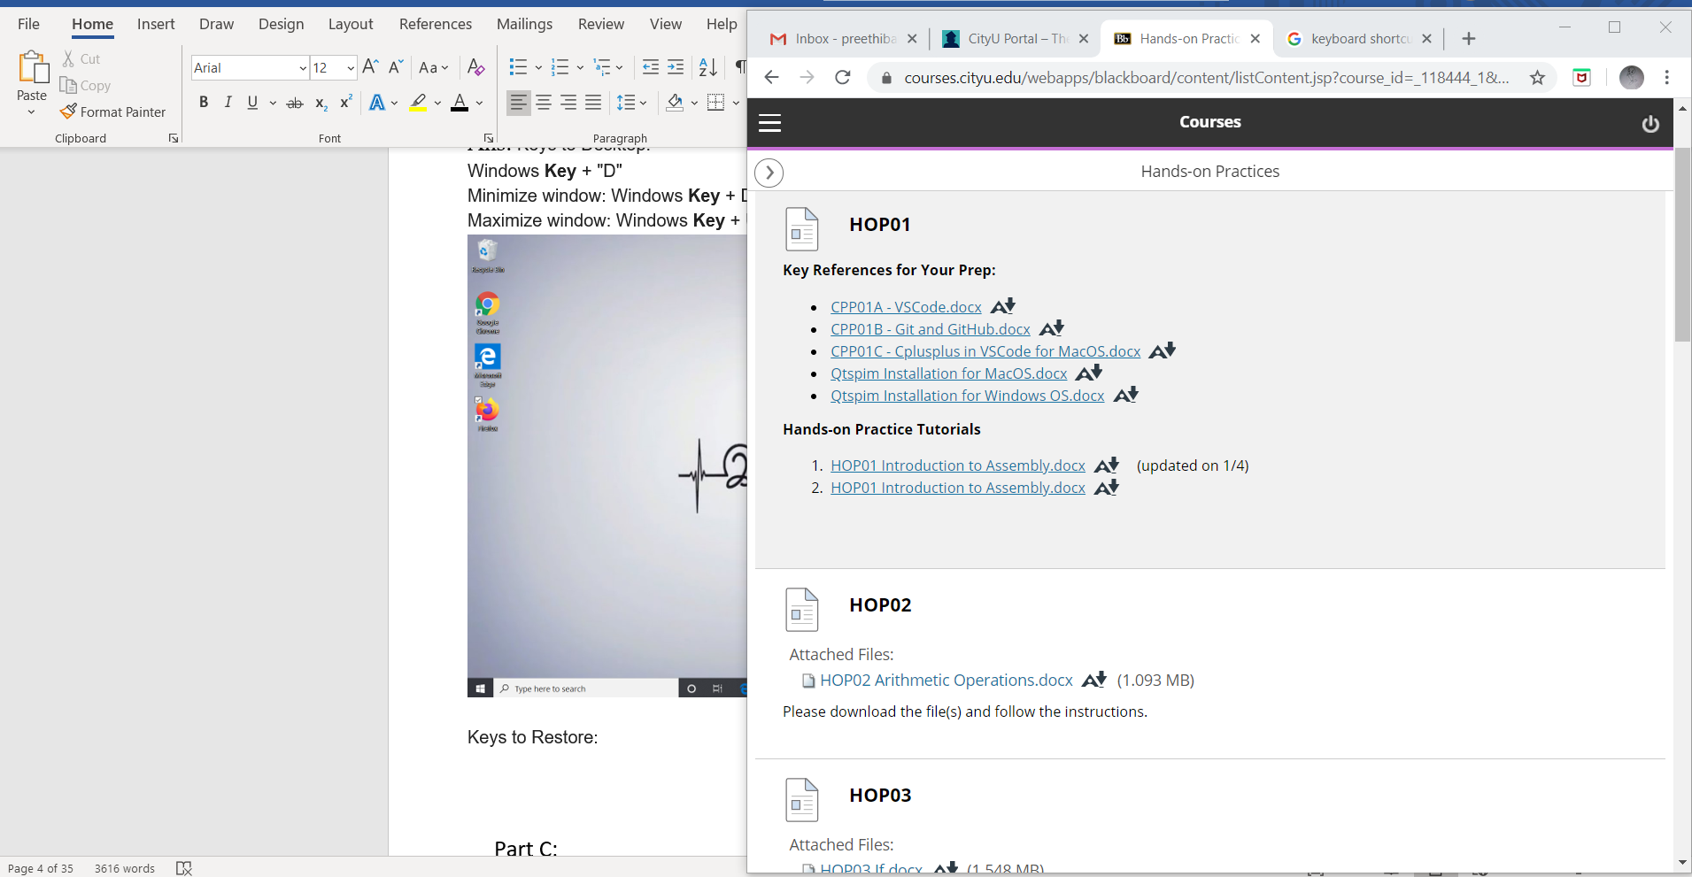

**Part C:**

You have too many windows/Apps open. Please specify the key/command to display the list Windows. Please capture the screenshot. E.G

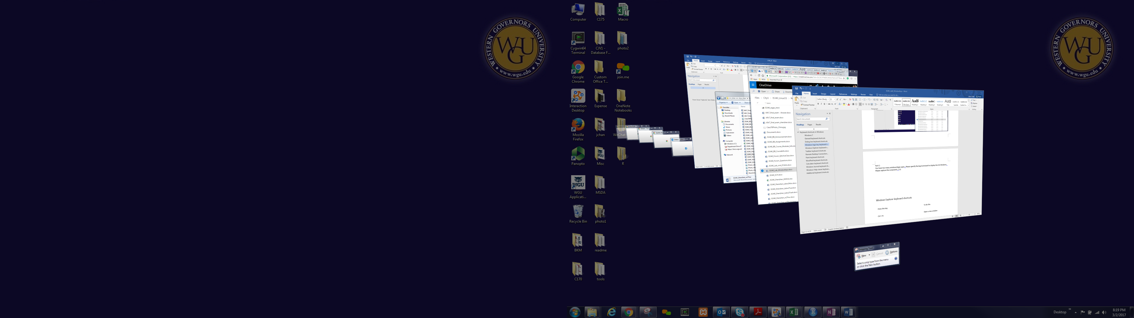

Ans:**Windows shortcut key** is Alt + Tab

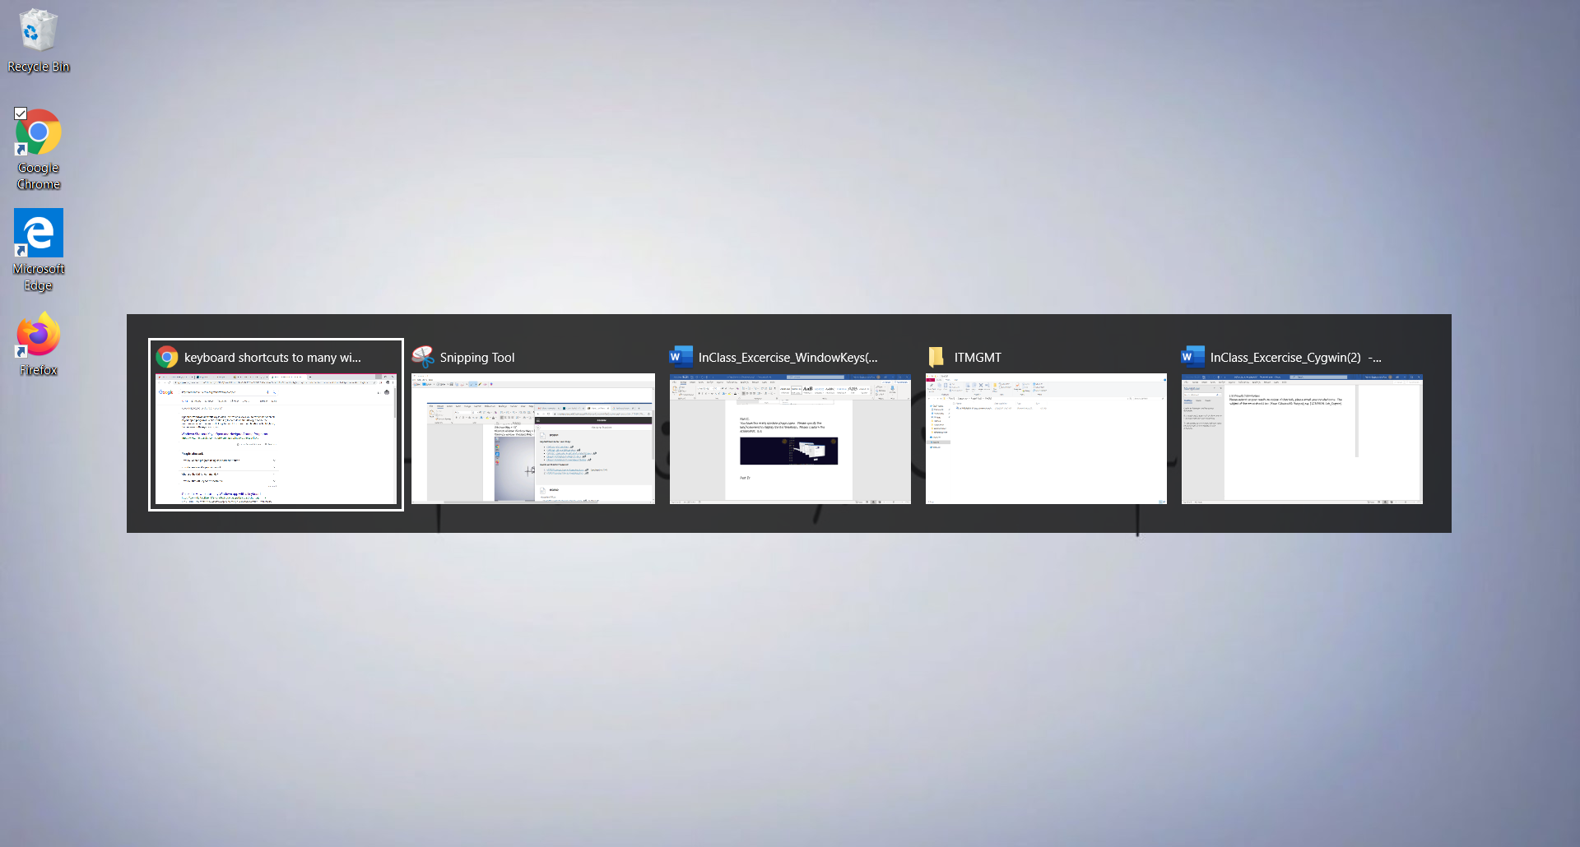

**Part D:**

How do you open a folder on your Desktop, while you have many apps (e.g. Chrome Browsers) open?

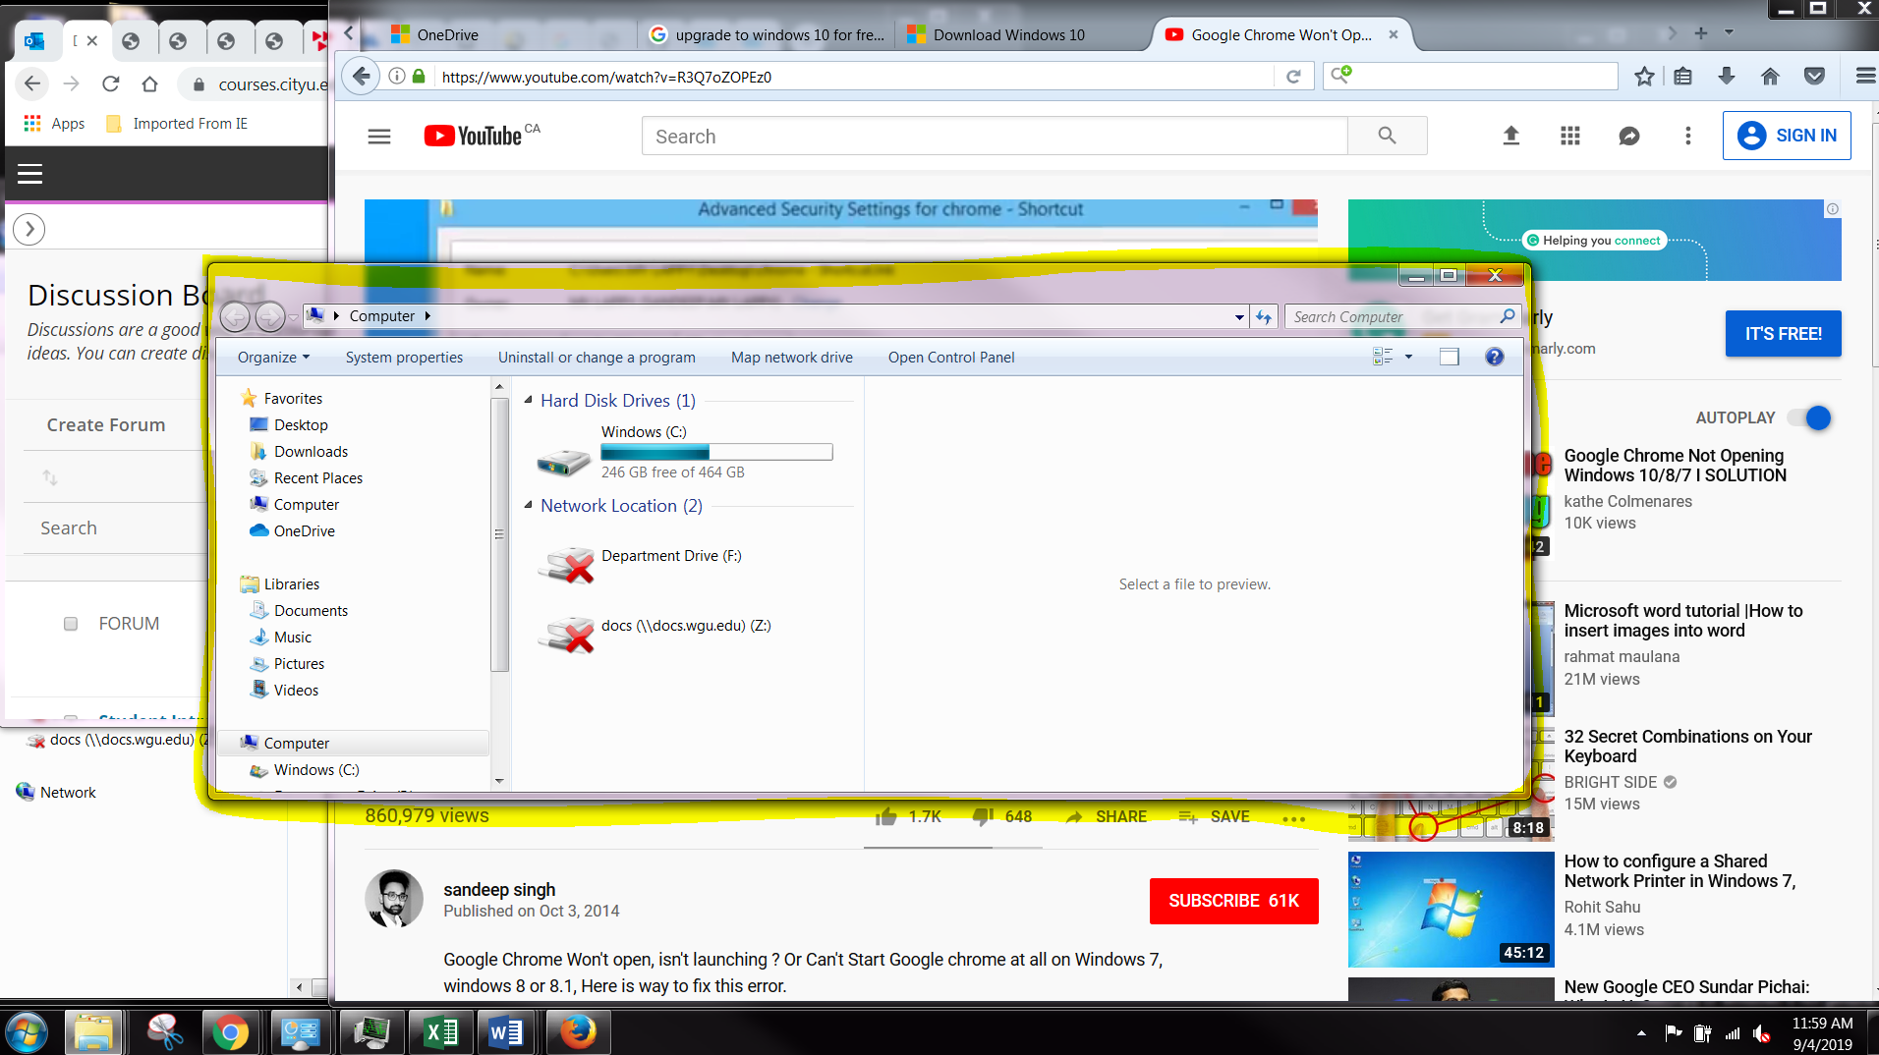

Ans:Key to Ctrl-O to **open** files

